**Citrix MS Teams Module**

Goliath Performance Monitor’s proactive monitoring and remediation can be extended by implementing the **MS Teams module** to ensure end users are running Microsoft’s Teams in HDX Optimized mode.

**To obtain Goliath's Citrix MS Teams module, please contact your Goliath sales representative.**

When users are not running in optimized mode, MS Teams performance is severely impacted and the overall user experience is degraded within their session. This leads to break downs and interruptions in communication as well as lost confidence in the tools team members are using.

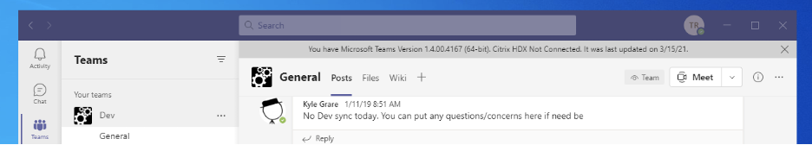  
**Figure 1: MS Teams running non-optimized**

Goliath’s MS Teams module ensures users are running the application optimally by monitoring vital services. If a service becomes unavailable, Goliath generates an alert and can automatically remediate the issue by restarting the service. Dashboards display which devices are affected and historical reports are available to document incidents as needed. In addition, you can use Goliath’s session display to ensure all VDI sessions are running with the latest supported Citrix Workspace version, ensuring Teams optimization support is available.

**NOTE:** The initial version of this module applies to users running Teams in a virtual desktops (VDI) environment only. When Teams is run in a published desktop (XenApp) Goliath can monitor and alert when Teams is not optimized, but will not have visibility into the user or session details. This module does not apply to users accessing Teams as a published application.

**Pre-Requisites**

* Goliath Performance Monitor v11.8.x or later
* Citrix Virtual Apps and Desktops (CVAD) v19.03 or later
* Goliath Agent installed on VDI devices or XenApp server
* Goliath Teams Module file

**Applying the Module**

* Import the module
  + - Copy the MS Teams Module MWA file to the Goliahth Install Directory which is one of the following on your Goliath server:
      * C:\Program Files (x86)\MonitorIT\WatchImpExp folder
      * C:\Program Files\MonitorIT\WatchImpExp folder
    - Go to the **Configure > Monitoring Rules** page in the Goliath interface
    - Click the menu button and then chose the submenu option **Import/Export Rules**.
    - In the dialog that opens, select **Import Monitoring Rules** and click **OK**.
    - Next, select the **Citrix MS Teams** module and click **OK**.  
      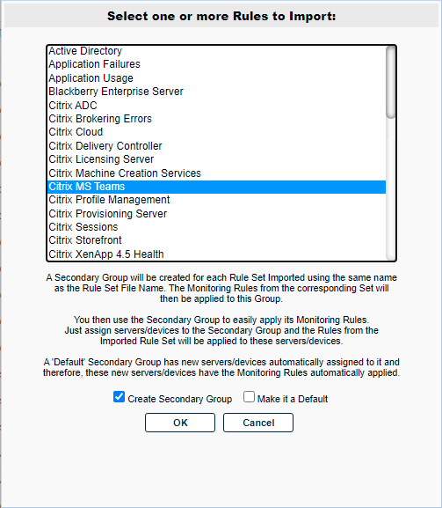
* Two new rules are added to the Monitoring Rules list:  
  
  + - Citrix MS Teams – Citrix HDX Redirection
    - Citrix MS Teams – Citrix HTML5 Video redirection
* Finally, edit each rule and add your VDI devices that your end users use to run MS Teams. Be sure to save the rules when done editing.  
    
  **Note:** In the case where the devices do not appear within the rule selection window, use the Assign Rules option from the Inventory page.